Traditional Approach before Node.js

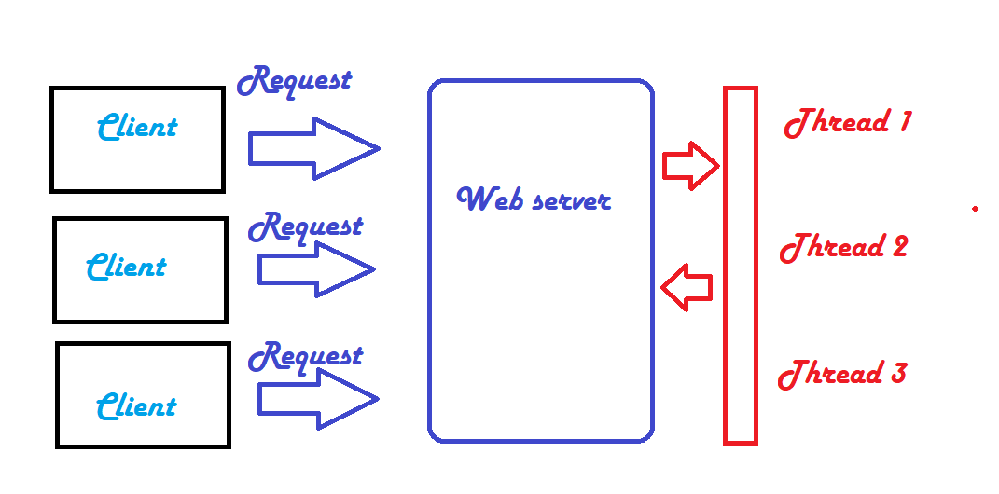

After Node.js

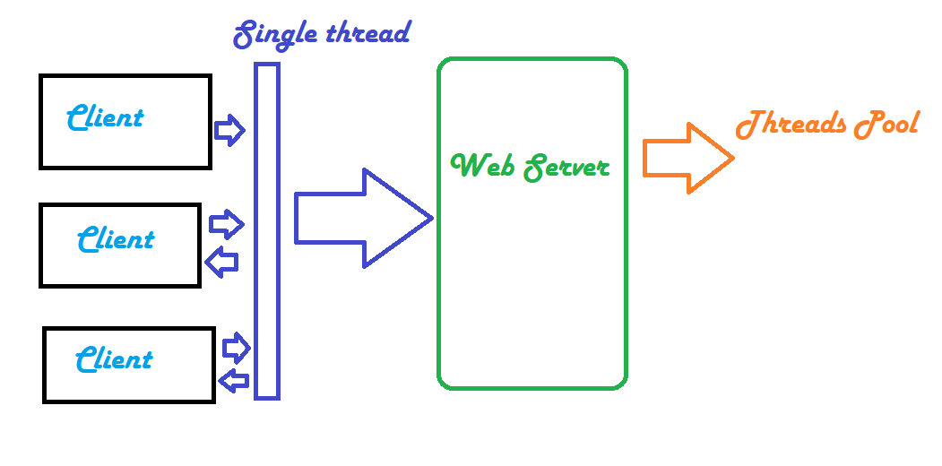

Node.js Modules

1. Core Modules
2. Local Modules
3. Third Party Modules
4. **Core Modules**
   1. http : includes all the classes and methods and events of http
   2. url
   3. querystring
   4. path
   5. fs
   6. util
5. **Local Modules**

Create the Local Module with name as “test.js” and place this code

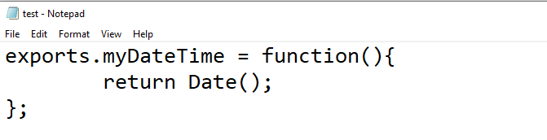

Create the new file with the name as “LocalModule.js” and place the below code

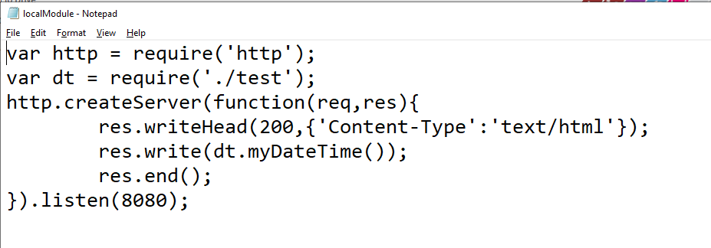

Go to command prompt and then type node localModule.js and then go to browser ping for localhost:8080

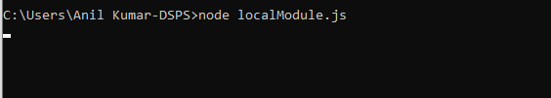

## Explanation of the above programs:

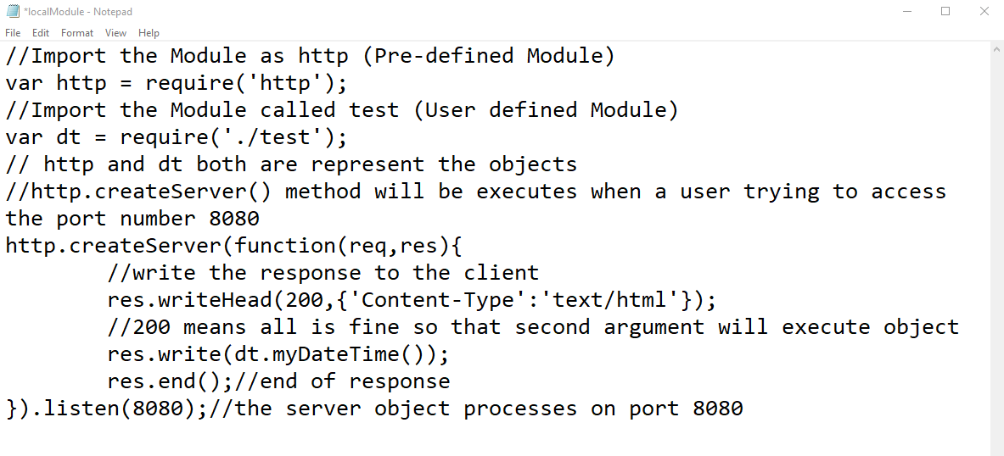

## Node.js as a File Server

1. Read file
2. Create file
3. Update file
4. Delete file
5. Rename file

First create the HTML Doc

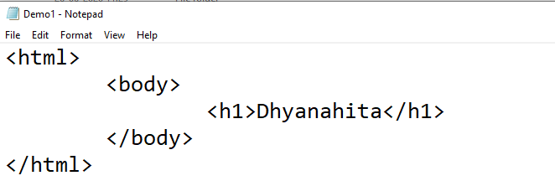

Create the node.js file

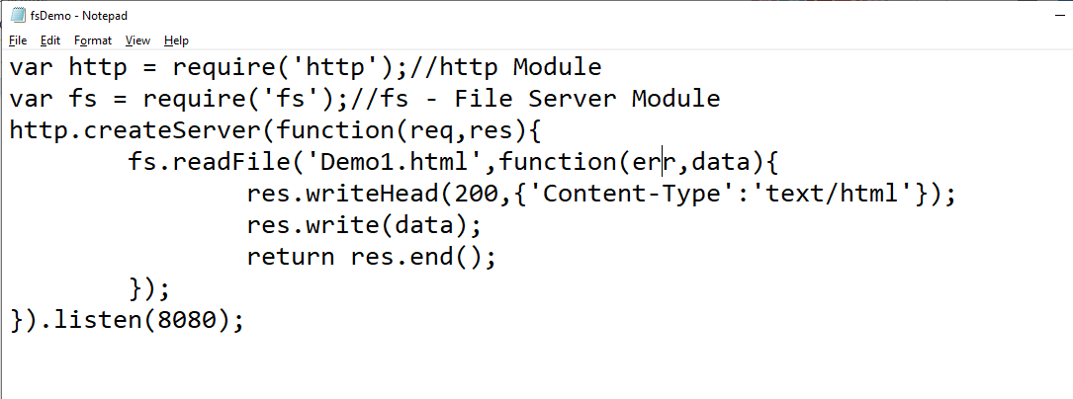



## **Task** : Create Html with some basic CSS with one or two classes, then load that file to node.js

## fs.appendFile() : It's for updating the existing file, it means let’s take an example of a text file and try to write some new data then it will update the existing file.

## fs.open() :

## fs.writeFile() :